ESTIMATION OF BUSINESS EXPENSES

# 1.INTRODUCTION

# 1.1 OVER VIEW

Estimating Business Expenses is an important step in determining how much money you need to start and keep your business running without encountering cash flow problems. A formula for calculating expenses in a business is; Total Expenses=Cost of Goods Sold +Operating Expenses.

# 1.2 PURPOSE

* Build Better Client Relationships
* Ensure You Understand What The Project Involves
* Help Estimate a Completion Date
* Help You Decide Whether to Take on the project.

# 2.PROBLEM DEFINITION &DESIGN THINKING

2.1 EMPATHY MAP

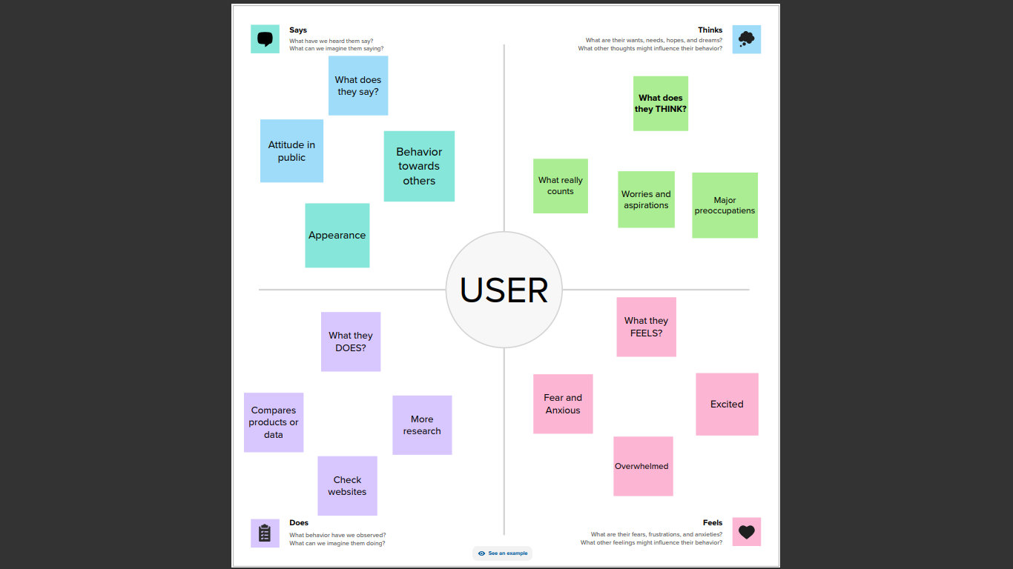

2.2 IDEATION AND BRAINSTORMING MAP :

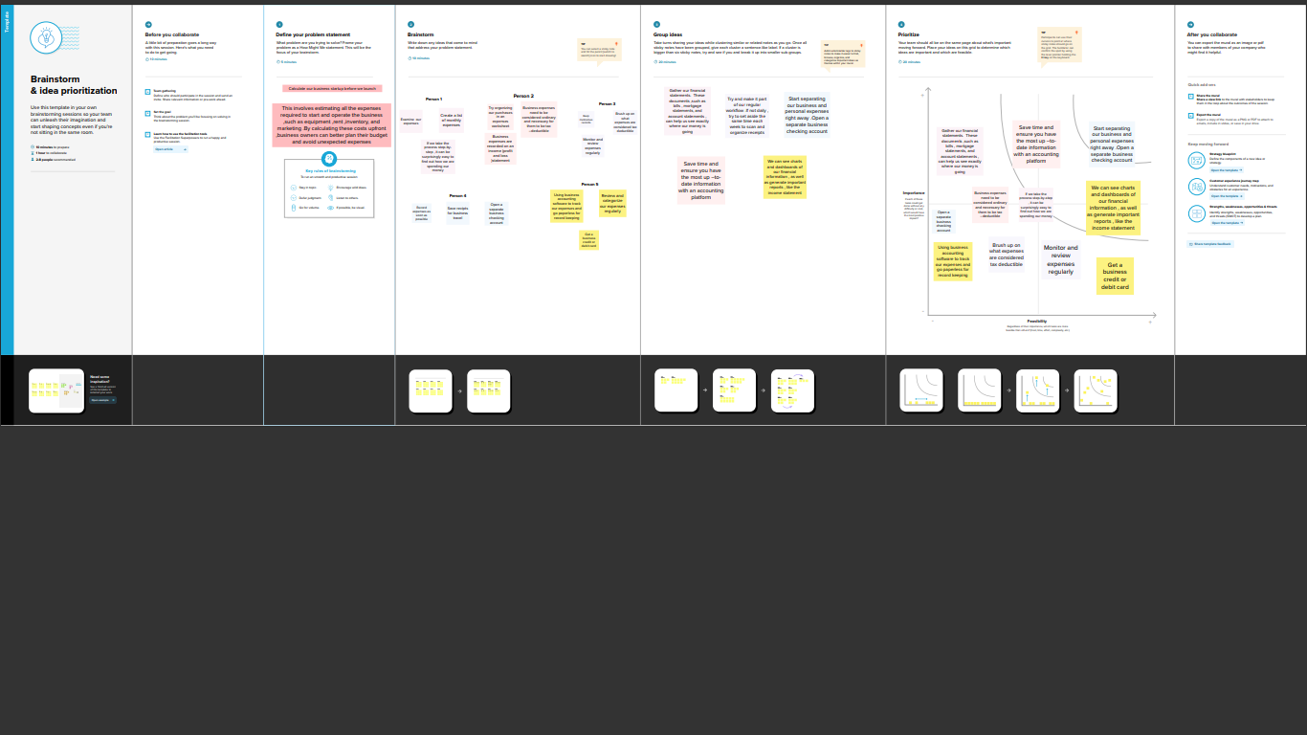

# 3 . RESULT

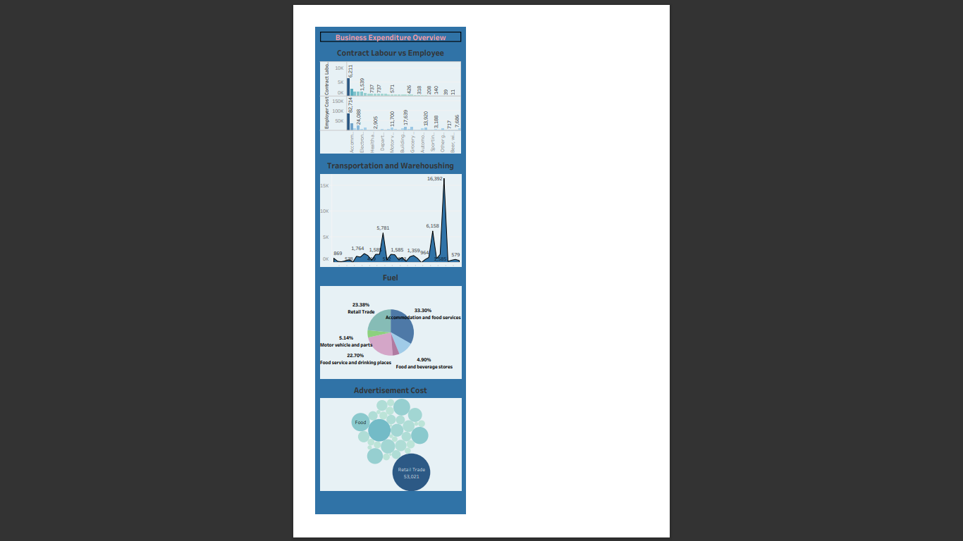

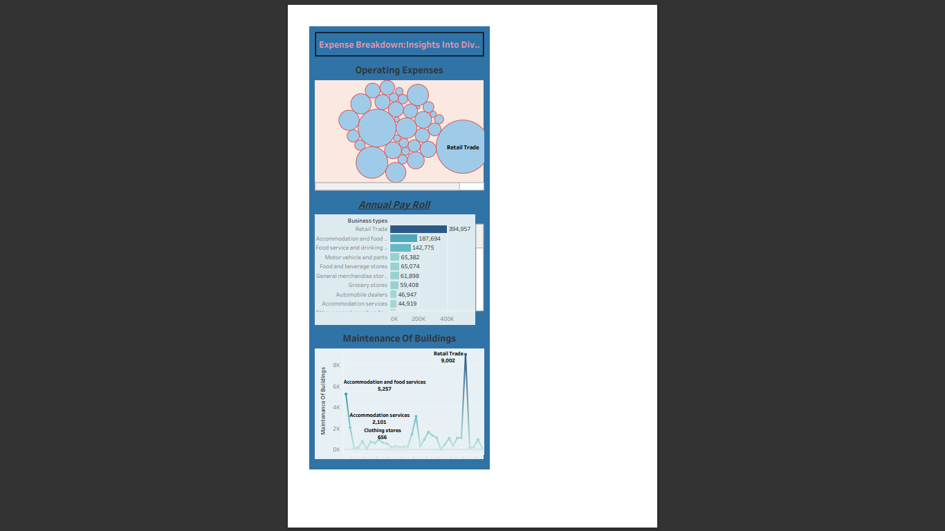

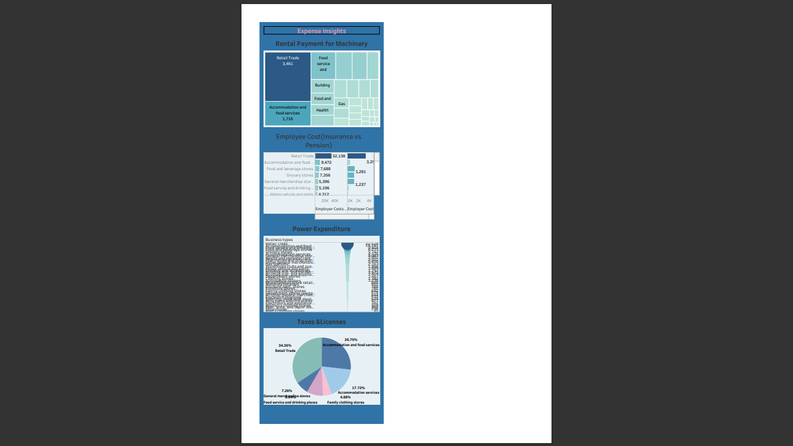

# 4. ADVANTAGES &DISADVANTAGES

|  |  |
| --- | --- |
| **Advantages** | **Disadvantages** |
| Helps in setting prices | Records past data |
| Identifies unnecessary costs involved | Costs keep changing every interval |
| Enhances productivity | Expertise required |
| Helps the management make effective decisions | Expensive maintenance |

# 5. CONCLUSION

In business, an estimate is a calculated guess of what something will cost. Estimates are often used in bidding for contracts or projects. They can also be used to find out how much material or labor is needed for a job.Cost estimation is an important component of project management that ensures projects are finished on schedule and within budget.

# 6. FUTURE SCOPE

Cost estimation sets the stage for a budget that will provide adequate funding to complete a project on time and in accordance with quality standards. Going the extra step and assigning budgets to various activities helps the team stay within the larger budget and avoid wasteful spending.